 | 
Solution Architecture
Date | 03-07- 2026
Team ID
Project Name | Smart Agricultural Production Optimization Engine (OptiCrop)
Maximum Marks | 5 Marks
Solution Architecture Diagram:
The diagram below shows OptiCrop's Presentation Layer, Application Layer, and Data Layer, along with the specific technologies and components used in each.
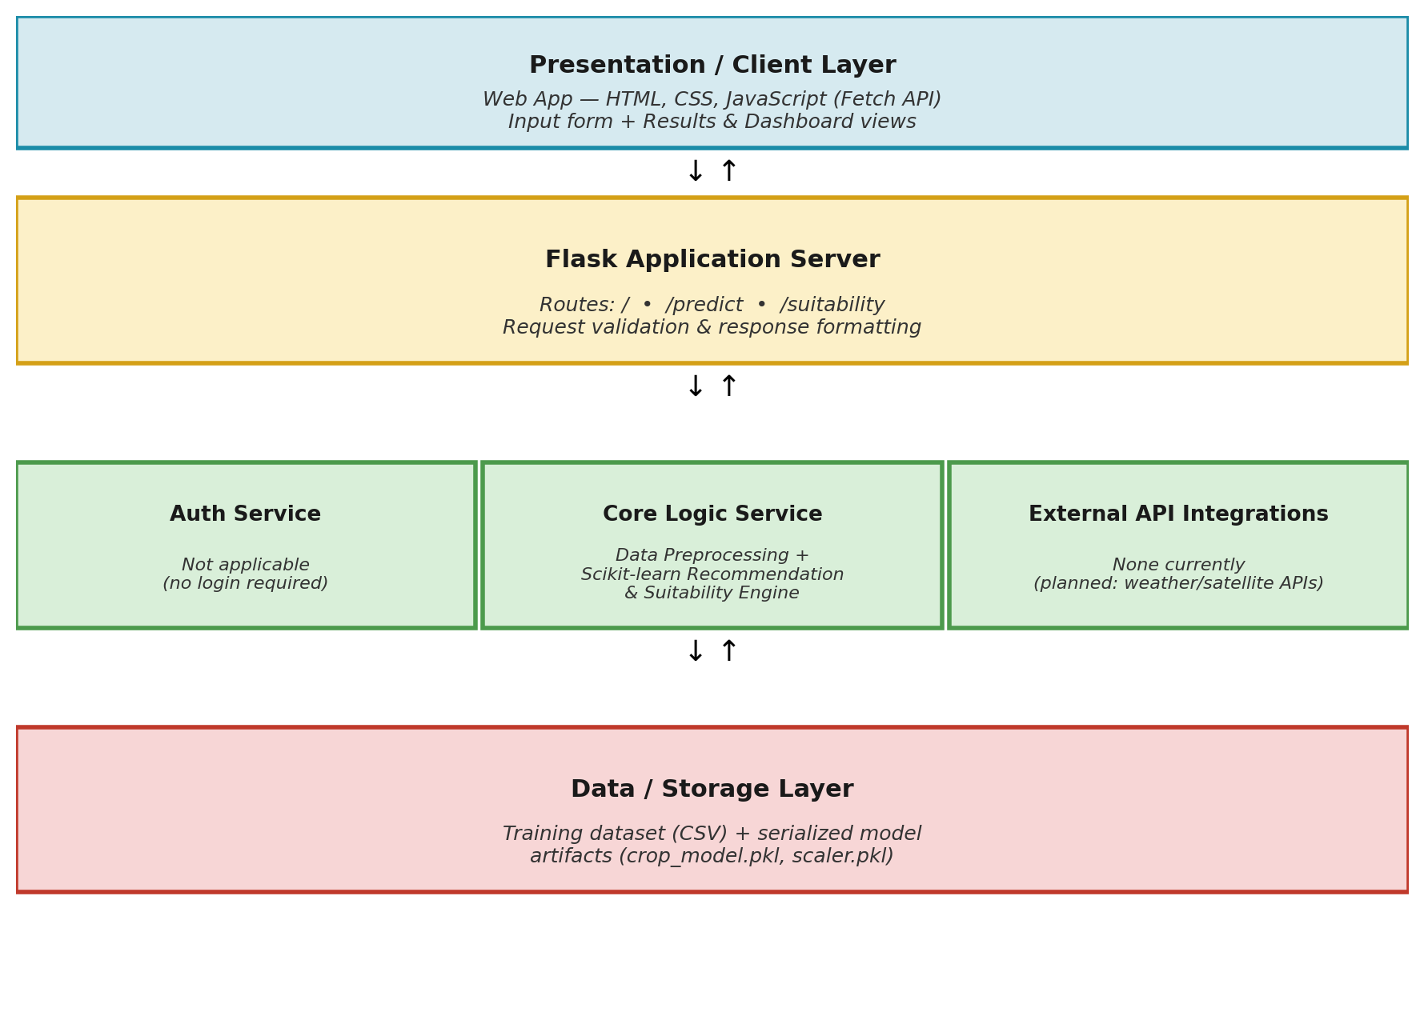
Component Description Table
Component Name | Description / Role in Architecture | Technologies Used
Presentation Layer | Renders the input form for soil and environmental readings and displays the crop recommendation, suitability result, or dashboard charts. | HTML, CSS, JavaScript (Fetch API)
Flask Application Server | Handles routing (/, /predict, /suitability), validates incoming requests, and orchestrates calls to the ML engine. | Flask (Python)
Core Logic Service (ML Engine) | Preprocesses input readings, runs the trained classification model, and generates crop recommendations and suitability assessments. | Scikit-learn, Pandas, NumPy
Auth Service | Not applicable in the current version — OptiCrop is a public tool with no login requirement. | —
External API Integrations | None in the current version. Planned for a future release to pull live weather or satellite data. | Planned: weather / satellite APIs
Data / Storage Layer | Stores the training dataset and the serialized trained model artifacts, loaded into memory once at application startup. | CSV dataset, joblib-serialized model files (crop_model.pkl, scaler.pkl)

